

**Veermata Jijabai Technological Institute, Mumbai 400019**

**Experiment No.:** 02

**Aim:** To perform various OLAP operations such as: slice, dice, roll up, drill up etc.

**Name:** Kiran K Patil

**Enrolment No.:** 211070904

**Branch:** Computer Engineering

**Batch:** D

**Theory:**

Online Analytical Processing (OLAP) operations are fundamental for analyzing and gaining insights from multidimensional data. They allow users to navigate, summarize, and manipulate data in a way that's tailored to their specific analysis needs. Here's a brief overview of various OLAP operations:

**Slice:**

Definition: Slicing is the process of selecting a single dimension from a multidimensional cube, thereby reducing the cube to a two-dimensional slice. It allows you to view a cross-section of data.

Example: If you have a three-dimensional cube representing sales data with dimensions for time, product, and region, you can slice the cube by selecting a specific time period (e.g., a particular quarter), resulting in a two-dimensional table displaying sales data for that quarter across different products and regions.

**Dice:**

Definition: Dicing is the operation of creating a subcube by selecting specific values or ranges along multiple dimensions. It's a more targeted operation than slicing and allows you to focus on a subset of the data.

Example: In the sales data cube example, dicing could involve selecting a particular quarter, a specific product category, and a particular region to analyze sales for a specific segment of the data.

**Roll-Up:**

Definition: Rolling up, also known as aggregation, is the process of summarizing data from a lower level of detail to a higher level within a single dimension. It allows you to view the data at a coarser granularity.

Example: You can roll up sales data from the product level to the product category level. This aggregates sales figures for individual products to provide total sales for product categories, simplifying the view of the data.

**Drill-Down:**

Definition: Drilling down is the reverse of rolling up. It involves navigating from a higher level of aggregation to a lower level of detail within a single dimension. It allows you to explore detailed data.

Example: From the product category level, you can drill down to see sales figures for individual products within a specific category, providing more granularity in your analysis.

**Output:**

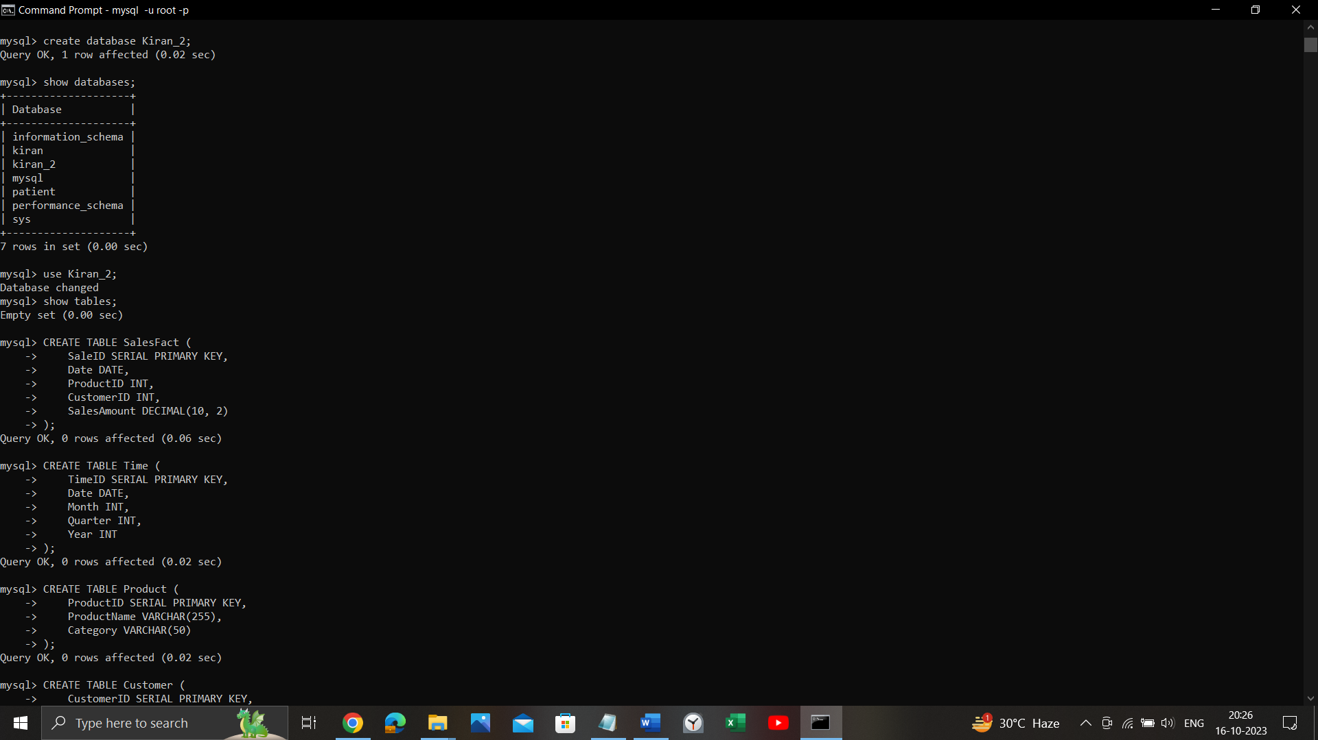

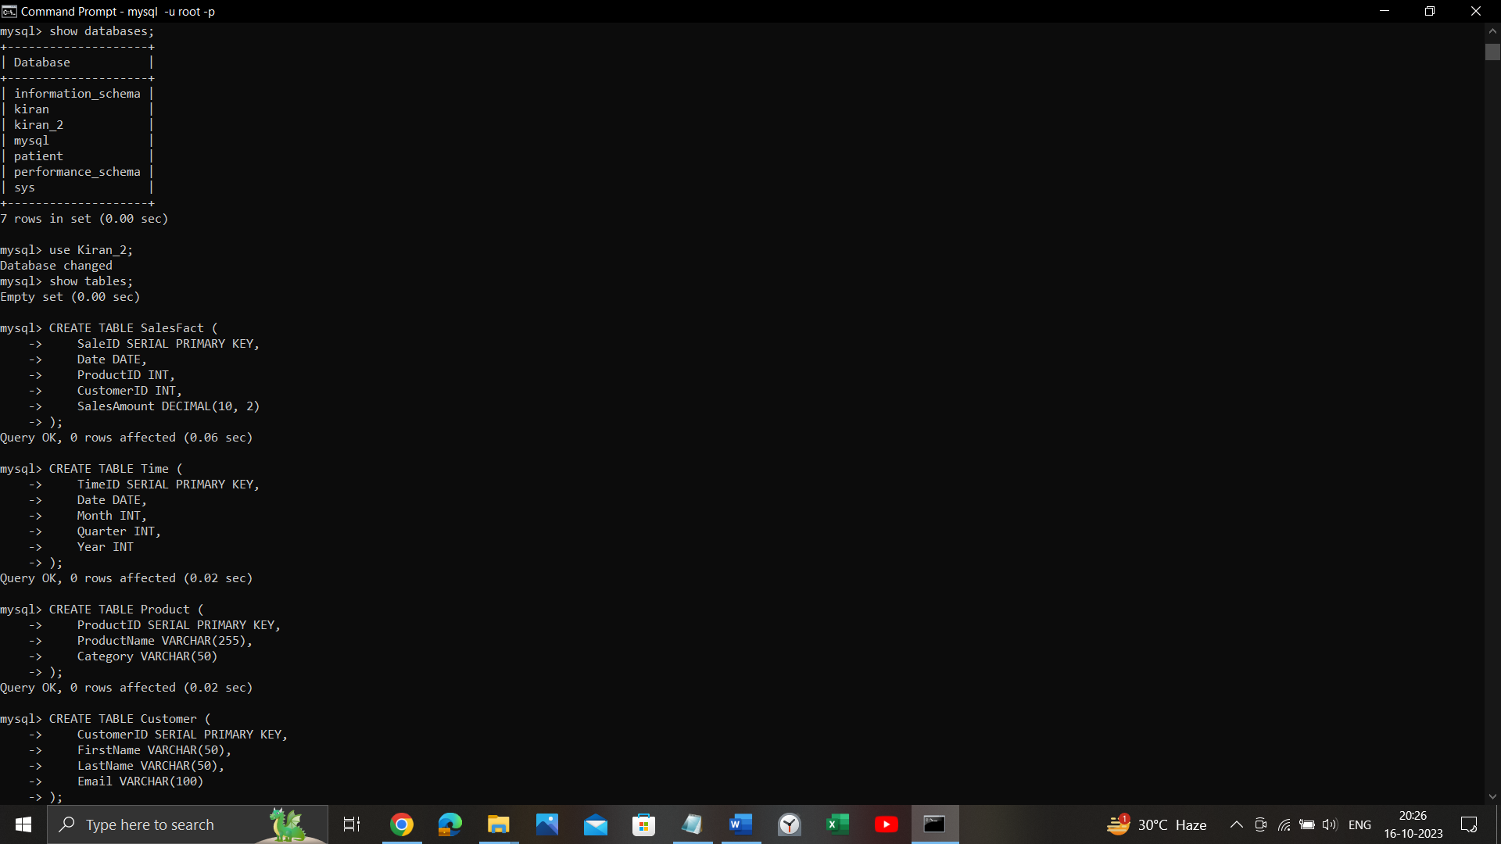



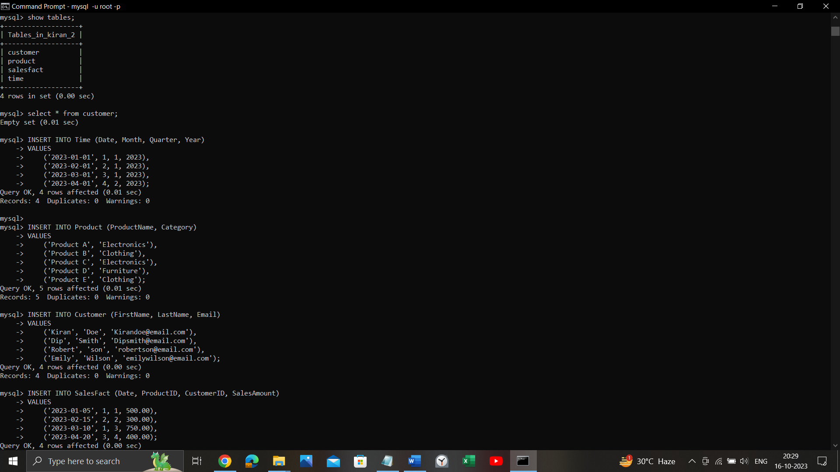

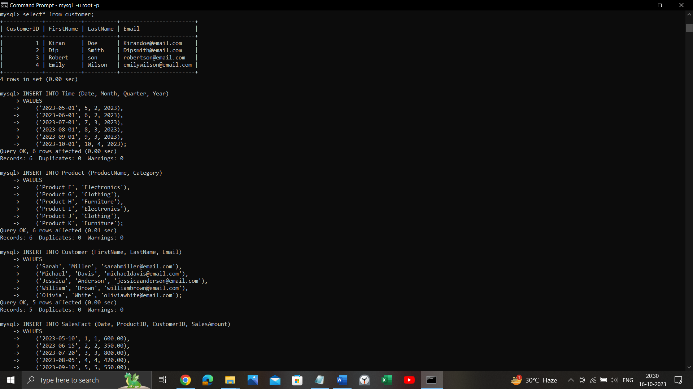

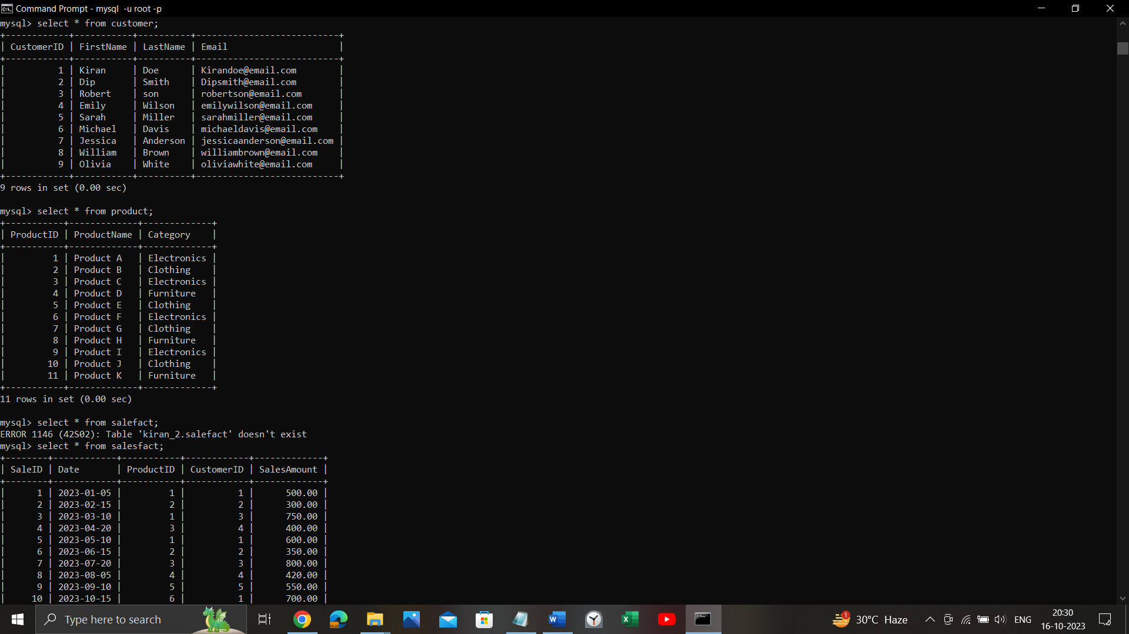

**1. Slicing**

**Operation:** Slice the data to view sales for a specific quarter (e.g., Quarter 2 of 2023).

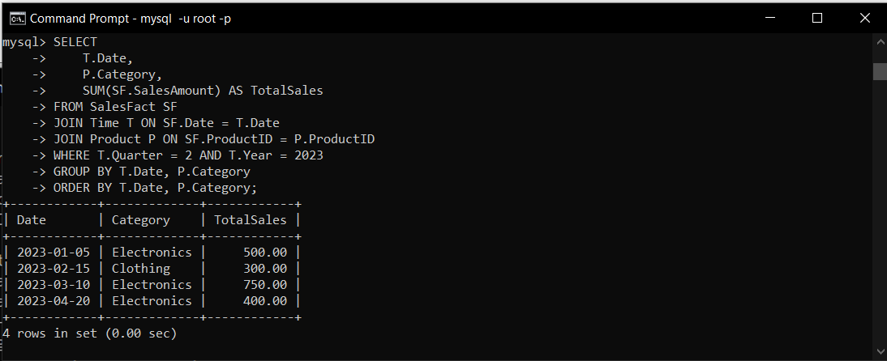

**2. Dicing**

**Operation**: Create a subcube to view sales for Quarter 2 of 2023 for products in the "Electronics" category.

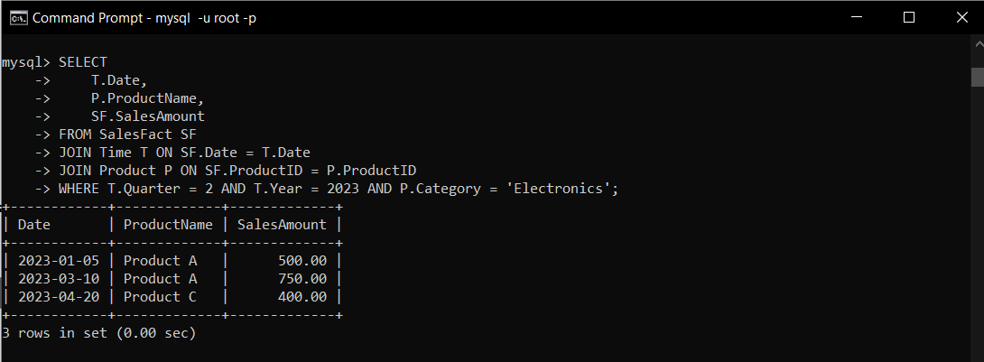

**3. Rolling up**

**Operation**: Aggregate sales from monthly to quarterly level for 2023.

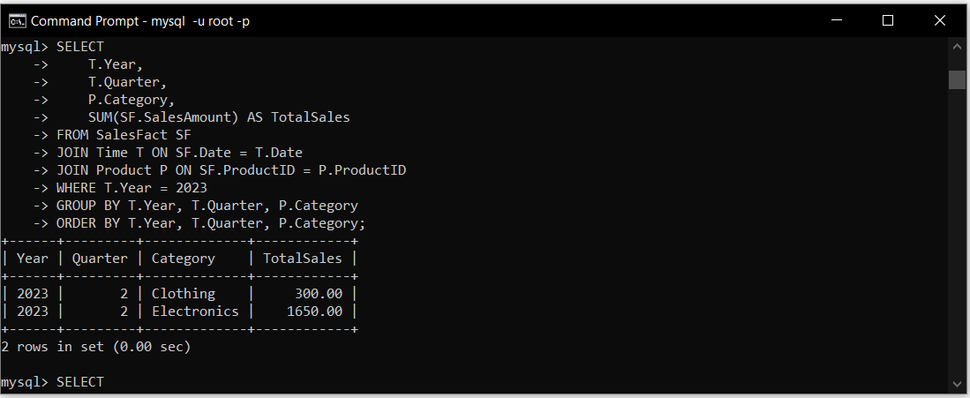

**4. Drill-Up:**

**Operation:** Navigate from quarterly sales data to monthly sales data for Quarter 2 of 2023.

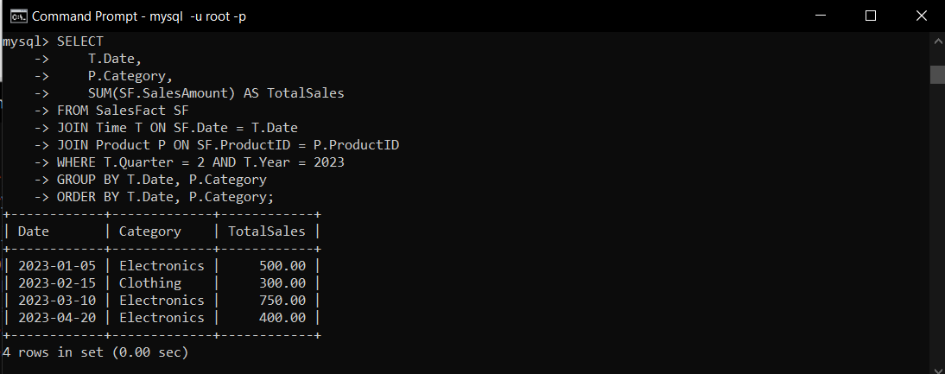

**5. Pivot:**

**Operation:** Pivot the data to view total sales by product category for each quarter in 2023.

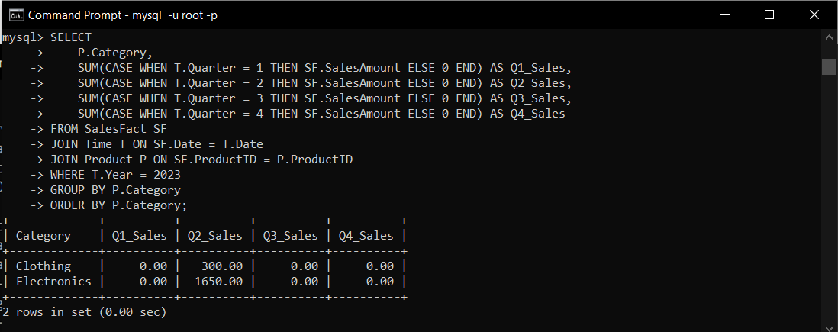

**Conclusion**:

In conclusion, Online Analytical Processing (OLAP) operations are essential tools for dissecting and interpreting multidimensional data. These operations, including slice, dice, roll-up, drill-down, pivot, and Top-N analysis, provide a versatile framework for users to navigate, summarize, and manipulate data according to their analytical needs. Whether it's narrowing the focus of data, drilling deeper for detailed insights, summarizing information for higher-level trends, or even reorienting data perspectives, OLAP operations empower users to derive valuable insights and make informed decisions from complex datasets. Understanding and skillfully employing these OLAP operations is vital for business intelligence and data analysis in various domains.